Services for the Visually and Hearing Impaired
Cookie Exchange Recipe Book
March 2022

No Bake Pecan Coconut Praline Cookies
Cassi Stahl

2 ½ C | Sugar |  | Time: 15 Minutes
½ C | Evaporated Milk |  | Servings: 12
½ C | Corn Syrup
½ C (1 stick) | Butter
1 tsp | Vanilla
2-2 ½ C | Chopped Pecans
2 ½ C | Shredded Coconut

- Set pecans, coconut, and vanilla off to the side.
- Mix sugar, evaporated milk, corn syrup, and butter in large saucepan.
- Bring to a rolling boil & boil for 3 minutes.
- Remove from heat & add pecans, coconut, and vanilla.
- Stir for about 4 minutes.
- Take a spoonful of batter and place on wax paper. Let it sit until batter has hardened.
- Remove from paper and enjoy.
Snowballs
Cassi Stahl

8 oz | Cream Cheese |  | Time: 15 Minutes
1 C | Crushed Pineapple, Drained |  | Servings: 24
2 ½ C | Shredded Coconut
1 C | White chocolate, melted (optional)

- Combine all ingredients
- Shape into bite size balls and refrigerate
- Optional: Dip in white chocolate or roll in additional shredded coconut

Buckeyes
Cassi Stahl

3 ½- 4 C | Powdered Sugar
1 ½ C | Peanut Butter |  | Servings: 24
2 Tbs | Milk
½ C (1 stick) | Butter
1 tsp | Vanilla
1-2 C | Chocolate, Melted (for dipping)

- Mix all ingredients except for chocolate until combined
- Add additional powder sugar as needed until you reach a dough like consistency
- Form into bite sized balls
- Chill in fridge or freezer until firm
- Melt chocolate in microwave stirring between 15 second intervals until smooth
- Dip buckeyes 3 quarters of the way in chocolate

No Bake Monster Cookie Dough Bites
Cassi Stahl

1 C | Creamy Peanut Butter
2 Tbs | Honey |  | Servings: 24
1/2 tsp | Vanilla
1/4 tsp | Salt
2 C | Rolled Oats
1/4 C | Mini Chocolate Chips
1/4 C | Mini M&M’s

- Combine peanut butter, honey, vanilla, and salt and mix till combined
- Mix in oats, chocolate chips, and M&M’s
- Shape into bite size balls and refrigerate
Cake Mix Cookies
Shirley
1 box (18-20 oz) | Cake Mix
1/3 C | Milk |  | Servings: 24
1/4 C (1/2 stick) | Soft Margarine
1 | Egg
1 C | Chocolate Chips
1/2 C | Coconut or chopped nuts (optional)

- Preheat oven to 375° F
- Combine cake mix, milk, margarine, and egg. Beat on low till stiff dough forms
- Mix in chocolate chips, coconut, or nuts.
- On a greased cookie sheet, drop rounded spoonfulls 2” apart
- Optional: roll dough in powdered sugar before placing on tray.
- Bake 7 minutes or till lightly browned
- Let cookies stand several minutes before removing from the tray.

No Bake Freezer Cookies
Linda Taylor
1/2 C (1 stick) | Butter
1/4 C | Milk |  | Servings: 24
1/4 C | Sugar
1/4 C | Cocoa Powder
1/4 tsp | Salt
1 tsp | Vanilla
1/2 C | Peanut Butter
3 C | Quick Oatmeal

- Melt butter in microwave (45 seconds)
- Mix in milk, sugar, cocoa powder, and salt.
- Microwave 2 ½ minutes, stir, microwave another 2 ½ minutes
- Add vanilla, peanut butter, and quick oats and mix well
- Drop rounded spoonfulls on parchment paper.
- Place in freezer to set up.
- On a greased cookie sheet, drop rounded spoonfulls 2” apart

Pecan Shortbread Cookies
Gaylene and Bob
3 sticks | Unsalted Butter
1C | Sugar |  | Servings: 36-48
1 tsp | Vanilla
1 tsp | Almond Extract
1/4 tsp | Salt
3 1/2 C | Flour
1 C | Pecans or Walnuts

- Preheat oven to 350°
- Mix butter, and sugar till creamed
- Add vanilla, almond extract, salt, flour, and nuts
- Refrigerate for 1 hour
- Scoop into walnut sized balls and flatten balls on cookie sheet (will not spread)
- Bake for 20-25 minutes

Browned Butter Chocolate Chip Cookies
Faith
2 C | Flour
1/2 tsp | Baking Soda |  | Servings: 24
1/2 tsp | Cinnamon
1/2 tsp | Salt
3/4 C (1 ½ stick) | Butter (cut in chunks)
3/4 C | Dark Brown Sugar (packed)
1/4 C | Sugar
1 Tbsp | Vanilla
2 | Eggs
4 oz | Semi-sweet chocolate chips (coarsely chopped)
1 C | Chopped Pecans (toasted)

- Mix flour, baking soda, cinnamon, and salt. Set aside
- In saucepan, melt butter over medium heat, cook 3-4 minutes until butter forms brown specks (begins to take on caramelized scent) stir occasionally.
- Pour butter into a separate bowl and cool slightly
- Add sugars and vanilla to butter and mix well
- Mix in eggs
- Stir in flour
- Refrigerate dough for 15 minutes
- Preheat oven to 375°
- Stir in chocolate chips and pecans
- On ungreased cookie sheet, drop rounded spoonfulls about 2” apart
- Bake 10-12 minutes or until golden brown
- Cool for 1 minute before removing from baking sheet

Chewy Honey Cookies
Dennis
1/4 C (1/2 stick) | Butter
2 C | Sugar |  | Servings: 36-48
1/2 C | Honey
2 | Eggs
2 tsp | Vanilla
4 1/2 C | Flour
4 tsp | Baking Soda
1/2 tsp | Salt

- Cream butter and sugar
- Blend in honey
- Add eggs one at a time
- Add vanilla
- Sift together dry ingredients (flour, baking soda, and salt)
- Add dry ingredients to wet mixture
- Refrigerate over night or for several hours
- Preheat oven to 350°
- Roll dough into 1” balls and roll in sugar
- Place on ungreased cookie sheet
- Bake for 12-15 minutes or until lightly browned

Cooking Tips
Set up your work area
- Gather all your ingredients ahead of time to reduce multiple trips around the kitchen
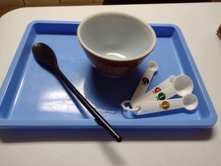
- Trays are useful for keeping your ingredients and utensils together at your workstation and if placed under mixing bowls make for easier clean up
- Keep a wet rag near your workstation for wiping hands and any small spills
Ingredient Storage and Labeling
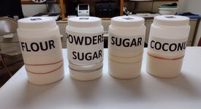
- Store ingredients such as flour and sugar (or other ingredients that come in bags) into rigid air- tight containers to make for easier holding and scooping
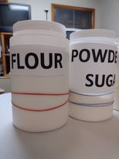
- Use large easy to read labels to mark ingredients, especially those in similar containers to prevent confusion.

- Rubber bands or raised dots can be used to provide a tactile means of labeling ingredients
  - Ex. place 1 rubber band around your flour and 2 around your powdered sugar.
- Electronic labels such as those from Navilens, or the Pen Friend allow the user to have the labels read to them using their phone or the pen device.
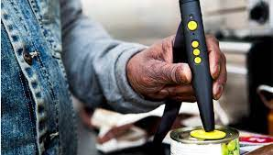

Measuring Ingredients
- There are many types of measuring cups and spoons available and different individuals may each find that a different one works better for them.
- Stacking measuring cups and spoons can be helpful for identifying the different sizes
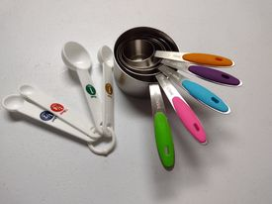
- Some are available with different color labels to aid with size recognition if the user is unable to make out the labeling

- Tactile dots or rubber bands can be added to help distinguish sizes

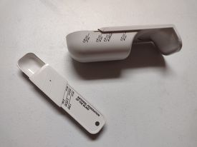
- There are some measuring spoons and cups that slide to become different sizes and have tactile cuing when slid into the correct position

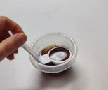
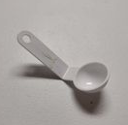
- Curved measuring spoons (ladle shaped) can be helpful for measuring small amounts of liquid ingredients such as vanilla, extracts, or milk. Store these items in small bowls and instead of having to pour into the small spoon you can then scoop the proper amount.

Helpful Appliances and Gadgets
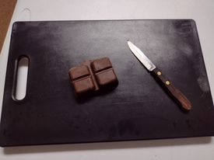
- Having a dark and a light cutting boards can aid with adding contrast and make it easier to see items being chopped
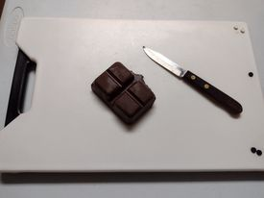
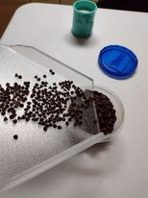
- Cutting boards with a narrow-curved end to aid with pouring chopped ingredients

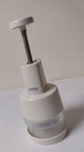

- There are some choppers for chopping small items that are enclosed and increase safety my limiting finger exposure to the blade

- An ice cream or cookie dough scoop can aid with creating similar sized cookies
